**Multimedia & Design:**

**Assignment 3 Project Proposal**

**And Project Progress Report**

Chris Ricard 0803354

Aidan Morbi 0806797

Sehaj Sahni 0704641

Department of Computer Science, Trent University Durham

COIS - MDST 2830: Multimedia & Design

Professor Priyanka Sharma

March 24th, 2025

**Project Proposal**

**Title and Objective:**

The project that our group has decided to make is that of a 2D platformer video game, which we are naming ‘Catventure’. The video game follows a cat, in which the player will control, making his way across platform-based landscapes in an effort to arrive at his cat bed. Being a 2D platformer, it is clear that this video game draws heavy inspiration from similar 2D platformers such as Super Mario Bros. and Sonic the Hedgehog. It was never a question in regards to what we wanted to develop. The three of us were very focused and excited to make a 2D platformer in the same vein of video games that we had spent our childhoods playing, but the challenge with designing the game came from how we would put our own spin on the game. Eventually, the three of us came together and pooled some ideas as to how we could differentiate our game from other platformers. The main idea that we conjured was “how can we take two things people love, and throw them together?”. We used the basis of Mario and Sonic to propel this idea. We knew gamers loved the challenging platform-based gameplay of Mario and Sonic, but the characters that are involved with those games don't really resonate with that of a mainstream audience. This may sound silly at first, considering those two characters are some of the most popular video game characters of all time, but taking a step back might help you understand what we mean. Yes, Mario (for example) is an immensely popular character, but at the end of the day he is just a plumber. We don't mean to generalize when we say this, but plumbers are typically not associated with video games. This same logic can be applied to Sonic the Hedgehog. Yes, he is an awesome character but hardly anyone's favorite character would actually be that of a hedgehog. We wanted to take a character or subject that a majority of non-gamers are familiarized with and apply that to a 2D platformer. The team at ngt-usorg states that generating a character for your game that resonates with audience members creates a sense of self identification, and thus a more attached gaming experience (2023). Keeping this methodology and information in mind when generating ideas for our game, we came up with the idea to make a cat the main character of our game, and design the world around said cat to fit the theme of what the world might look like from his eyes. The game wasn’t about simply plotting a cat into a world that resembles that of a Mario or Sonic game, but rather shaping the world around the cat through the eyes of the cat. Our character isn’t attacking goombas or looking to foil Dr. Eggman's evil scheme, but rather he is looking to collect yarn and fish, while traversing the world sporadically, jumping from platform to platform. Although it might seem silly at first glance, the world building was crucial for immersing the players into our game, and making them feel a sense of glee or cuteness while playing. In real life cats are often known to jump all around an owner's house, bouncing from the top of a couch towards the end of a cabinet. They want to eat fish, or play with yarn, and as previously mentioned all of these are featured within our game. Having a cat platformer is almost a joke that writes itself, considering how cat’s real lives usually involve playing a platformer as they traverse across their owners home.

To centralize this section a little more, the purpose of our project is to provide players with a not too challenging video game experience in which they can interact with our site and play our game in a way that they would with any other 2D platformer of a similar archetype. With that being said, our site does focus heavily on interactivity, considering it is a video game. Often, contemporary platformers are seen as extremely difficult, and sometimes even brutal in terms of level of difficulty. We thought, all though it would be ironic to make our game extremely difficult, that would simply not fit the theme of our game whatsoever. Due to this thought process, we decided to make our game relatively easy, to fit the cute nature of our game, and give gamers a relaxing break from any stresses that they may be undergoing in real life (or even use our game as an escape from the regular brutal difficulty of similar contemporary platformers). The team over at GLS states that easier games are necessary for gamers because they can subtly improve cognitive skills, and reduce stress or anxiety generated from real world activities (2025). This was another one of our key purposes when generating this game, that being subtle cognitive skills. We fully understand that there are a plethora of ways for not just gamers, but people in general to test their cognitive abilities, whether it be with a fast paced game or online cognitive test. However, sometimes these tests do not have to be as fast paced or intense as many people think. A relaxing game that you can turn your brain off while playing is fantastic for individuals who want something to do that ignites their brain, but don't want something that could possibly be a contributor to their real life stresses. Even if to the naked eye this video game may seem relatively easy and simple, the purpose of the game goes far beyond the distribution of a challenge towards players.

Now let's move onto the target audience. The audience in which we are aiming to focus on are that of adults who may be influenced by nostalgia, and younger individuals looking for a cute gimmick of a game. Firstly, nostalgia will be a big component of our marketing mix, as this game caters to older individuals who grew up playing previously mentioned 2D platformers such as Mario and Sonic. These individuals would have played games like these all throughout their lives while they grew up, and now may be looking to play a game that is similar in genre, but updated for modern audiences. The team at Games Fnadom.com states that nostalgia can be an extremely positive component of a game if executed correctly, which involves increasing sentimental connection for the players gaming experience, and an increase in player retention (2024). The key feature that we want evoked through the feeling of nostalgia in our players would be having the player think “hey this is similar to this game I used to like”. This encourages the player to play our game through the prospect of achieving the same bliss they felt when they played games such as Mario for the first time. You may ask why the player wouldn't just play Mario again, and that is a question held with validity. However, the answer as to why this target audience would choose our game over others is because the game is not Mario, rather it is like Mario. This adult generation of gamers would prefer to play a title that evokes a similar feeling to their childhood games, rather than the exact same feeling they had. In a way, that is what nostalgia is. It is not the exact same feeling they had as children, but rather a small spark with a pinch of nuance to evoke a similar feeling of gaming as a kid, rather than a blatant copy. Shifting focus to another sample from the target audience, teenagers would also find this game to be relatively fun, thus we want it to appeal to them as well. This is where the design elements of cuteness come into play, as most young teens have some level of affinity to cute animals such as cats. This could also result in positive word of mouth marketing between teens at school, as if they play our game during class on their computer word could get around about our game. This is to say that our game isn't just appealing to teens who play video games everyday, but rather the average teen with little to no knowledge on video games. That's why we focused more on the experience of stress relief and cuteness, rather than ridiculous difficulty.

We want teens to talk about our game in terms of “the cute stress-free cat game”, rather than “the brutally hard stress-inducing cat game”. We strongly feel like this demographic would also be great at promoting the game online, and could make the player pool increase even more with online exposure. The last target audience we have may be the most obvious, and that would be younger children. This one is relatively self explanatory, as young kids should be naturally drawn to a game like this. It is easy, easily accessible, and relies on a cute gimmick. This is an audience we can almost surely expect to flock to our game. The game is designed to be heavily child friendly, and we hope it can be what Mario was to gamers from past generations.

**Technology Stack:** HTML5, CSS3, JavaScript (Vanilla)

**User Flow:**

Let's shift focus over to user flow, and how we can expect individuals to navigate through our game. The user flow of our site (game) will follow a similar user interface of most linear based 2D platformers. Users will start on a main menu screen which will have clear typograĥy and graphics that are clear, mitigating any sort of confusion that could be caused from a clustered starting screen. After users advance past the start screen, they will be prompted to follow the simple instructions on how to actually play the game. Here is where the player will understand the simple user controls, and comprehend the goal of the game. The controls are simple enough, as they follow most computer based 2D platformers. They will either use WASD or the arrow keys on their computer to traverse each level, and should aim to reach the end of the level where their cat character will get to rest in his cat bed. Like previously stated this is an extremely linear game due to the purpose aiming to relieve stress and appeal to a large audience of individuals. After this section, the user will be prompted to select the level in which they would like to play. Each level contains different terrain and obstacles that must be traversed in order to reach the cat bed, thus completing the level. Levels will be unlocked after completing the previous level, and by completing all levels the user, in theory, will beat the game. Once the player completes a level they will receive a ‘winner’ screen where they will be told that they have beaten the level, and they will be able to move onto the next level of the game. The game flows extremely similar to that of a game like Mario or any other generic platformer. This, however, is not a bad thing, as a fun game loop like this is crucial for players to get a feel of user flow within the game. Joss Querne of Medium states that user flow for games is integral for a games success because of the fact that games are sequential, and that sequential context is above all else when designing successful user interfaces (2024). Our game follows this structure due to this exact reason. Context is the key for our game, as each screen that provides integral information must proceed one that also contains required information that should be understood above all else. Although the menu screens and flow may seem basic from a players perspective, the flow certainly happens for a reason. For example, what good would an instruction screen be if it only pops up once you have beaten the level? It would be nice to know how to play the game before you start playing, rather than after you have actually beaten it. As for expected user interactions, the entirety of the project is based on user interactions, so there are a plethora of these included within the game. As previously mentioned, users will navigate and interact with buttons on screen as they see fit to navigate throughout menus, eventually selecting a level to play. There is nothing particularly intuitive about the menu design, as a menu design should be universal. Alex Avard of GamesRadar states that video game menus are a universal tradition, in which little to no rules are often broken (2020). This is because of how universal they are in terms of navigation. Sure, more advanced games may make their start up screens more visually striking, but they all follow the same structure in terms of being the first things players see when booting up a game. This was the basis behind all user interaction within the game; that is making all controls and navigation be as straightforward and universal as possible. Meaning screens are navigated through the press of a button, and levels are selected through the same manner. The controls of our cat character also follow the exact same that usual platformers do so that, even if someone didnt read the instructions, they could most likely figure out how to play the game through prior understandings of other games.

**Project Progress Report**

**User Personas and Accessibility Strategy:**

Shifting focus on user personas, we have generated two user personas who we expect to be interested in playing our game. The first of which is Liam, who is a nine year old elementary student. Liam enjoys animals, so he is heavily interested in playing our cat themed game, and is ecstatic that it is free to play. Liams goals include that of playing a fund and engaging game which features easy to understand gameplay mechanics. Liam also loves games such as Mario, and Sonic. Liams main focus when playing a game that fits these goals is to derive a sense of achievement through the collection of in-game rewards, such as coins. Some frustrations that Liam has with contemporary games are difficult controls (due to his smaller stature), and instructions that rely far too heavily on text. Liam prefers his user interfaces to be more visually appealing than text-based, and plays games on his moms desktop. Liam was designed to be the average elementary school kid who would most likely be infatuated with our game. We took the character of Liam into account heavily when designing this game, and wanted his needs to be satisfied more than any other demographic. Liam’s needs are met in a variety of ways. We implemented collectibles such as yarn and fish for players like Liam to collect as he plays, which will help him to derive a sense of achievement while playing. The game's difficulty is also extremely easy, so that players like Liam can derive pure fun through the game, and not get upset when the game becomes too hard. We made sure the controls were very easy to understand, so that Liam does not become frustrated when trying to learn how to play. Considering Liam plays other games on his mothers desktop he should have a relative understanding of how a platformer plays. Even if Liam cannot immediately figure out how to play the game, he will find the instructions very useful and simple to navigate as he will not have to read much of anything, as the instructions are visual based. Liam will also derive enjoyment through the visually appealing user interface as it is cat themed, and he will be even more ecstatic to find out he can play the game on his moms desktop.

We designed the game to make sure Liam can derive some level of achievement through the collection of collectables, and to constantly make sure there is little to no confusion for Liam while he is traversing through the game. Another big component of designing this game for a demographic like Liam is to help with his self esteem. Teri Llach of Tynker states that one of the most important things children can achieve through playing video games is that of self-esteem (2023). Children as young as Liam are usually not capable of cognitively processing that the game they played was easy, and as long as a level of achievement is obtainable within the game is possible, this should suffice to give players like Liam a small boost of self-esteem.

The second user persona that was created was Tanya, who is twenty seven years of age who is an extremely casual gamer suffering from colorblindness. Her goals include playing a relaxing game, and not having her colorblindness ruin any fun that she could have while playing the game. Her frustrations include any games that include too much reliance on colour, and games that have a lack of customization options in terms of colour. Tanya also favors games that can be played solely through a keyboard, and loves games that have a myriad of accessibility features. Tanya’s goals are met through our game due to its extremely simple and chill gameplay loop. The difficulty of the game will not be a detriment to her whatsoever, and neither will an over reliance of colour on our end. Although the game has colour to spice up the visuals, the gameplay does not require users to be able to see colour, it's more of a visual bonus. Our game includes virtually no reliance on colour, and even features a colour blind mode that Tanya can turn on in order for the game to be adjusted more in her favor. We offer a plethora of customization options in terms of accessibility, and the game can be played solely through a keyboard, this way the game is completely favored for a player such as Tanya. Gerardo Molina of GameRant states that the importance of a colour blind mode for a game comes from perspective and clarity, so that the user is able to fairly see any trials in their view (2024). Tanya being able to see the platforms and obstacles that her cat must face is crucial to actually completing the game, so including a colour blind mode was a no-brainer for us, especially since our motto when designing the game was to allow the game to be very accessible for the most amount of people possible. With this segment ending, we can quickly transition into a discussion regarding our accessibility features.

As previously discussed, we will be implementing a colour blind mode to ensure anyone living with this condition is able to play our game with minimal stress involved. Most of what needed to be said in regards to a colour blind mode was stated in the previous section, so we will keep discussion on such a model relatively brief. In short, a colour blind mode does not take long to generate and can be one of the biggest features holding back certain players from playing our game. We have also dabbled in the idea of generating audio cues that will assist players with visual perception impairments. Sound cues such as alerting the player when there is a collectible nearby, or when they should jump have been discussed and will be further implemented. Another accessibility feature we have added to Catventure is that of adjustable game speed for the user to customize to their liking. This allows players to play at their own pace, so that everyone's playstyle can be integrated into our game, leaving no one feeling left out. We also will be attempting to implement customizable controls in an effort to up the ante in terms of customization for our game. This means that no matter the size of your hands or the flexibility of your fingers, you will be able to map controls to keys that will be most beneficial to you. A Lot of gamers (ourselves included) might drop a game in its entirety if we cannot control it in the exact way in which we want to, so this feature is crucial to reaching a broader player base. The last major accessibility feature that our team wants to implement is that of an accessibility settings menu. Our main focus with this feature is to centralize accessibility options, and keep them all in one place. This mitigates user frustrations and allows for players to customize their gaming experience with the utmost efficiency.

**Wireframe: Home Page**

*Low-Fidelity Design:*

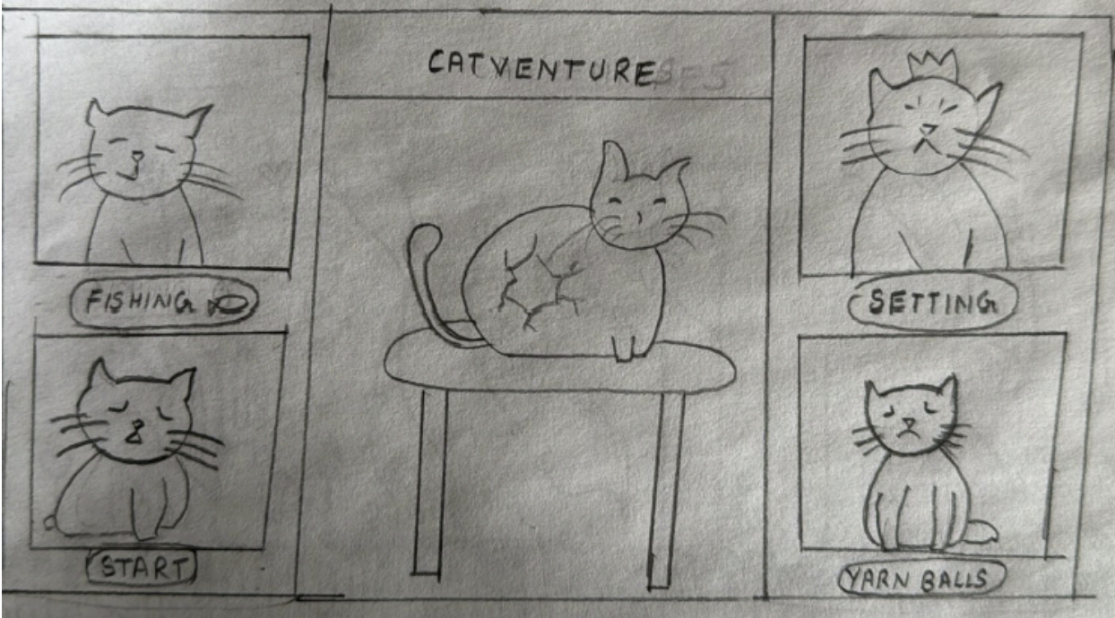

*High-Fidelity Design:*

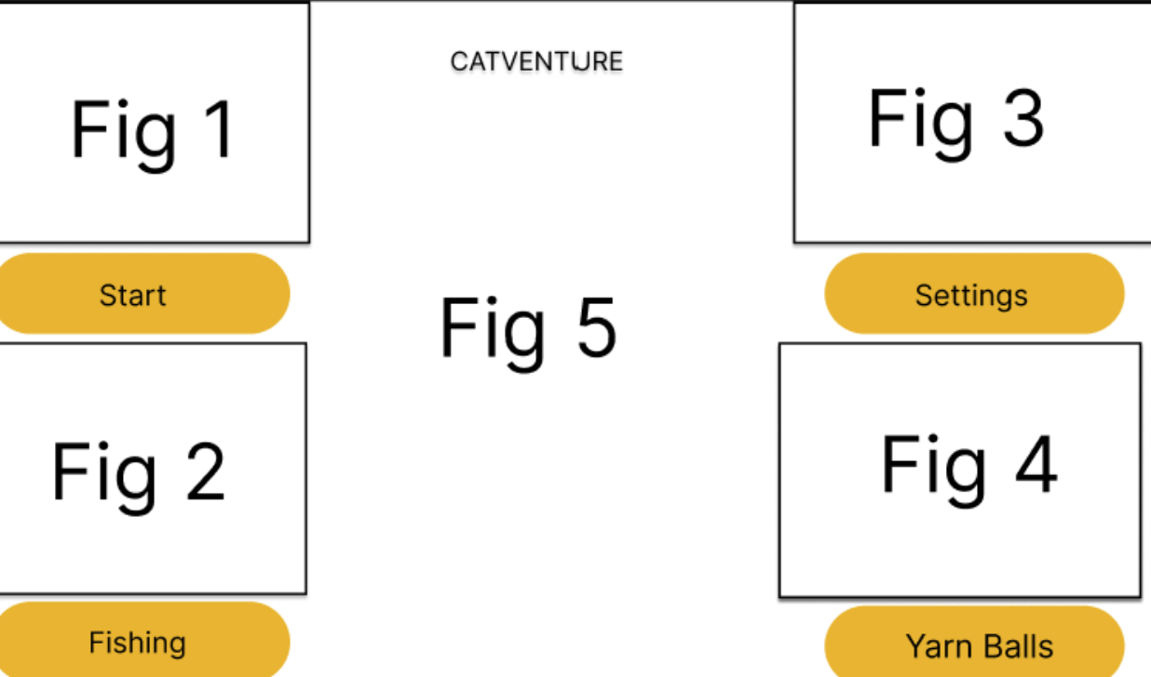

CATVENTURE's home page, or main menu, probably has the title "Catventure" and items like "Start Game," "Check Levels," "What is fishing," and "Adjust Settings." Players can start a new game, view their statistics, control character information, and quit the game all from this screen.

This menu is significantly shaped by the shift from low-fidelity to high-fidelity design. The home screen most typically begins as a low-fidelity wireframe in the early phases, with placeholders and simple forms being used to create structure. This version prioritises navigation and layout over looks. As the design develops, it enters high-fidelity, where interactive features, colours, font, and iconography enhance the user experience. Animations can be added for more seamless transitions, buttons become aesthetically identifiable, and backdrop imagery improves immersion. This development guarantees that the menu not only works properly but also complies with user expectations and the game's visual aesthetic.

**Mockups: HomePage**

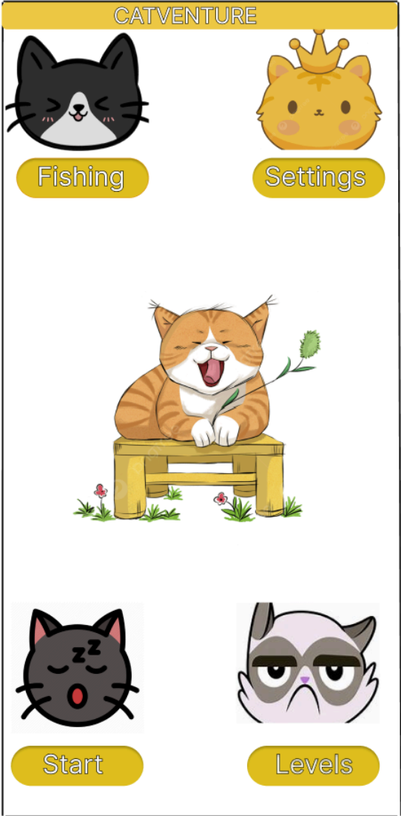 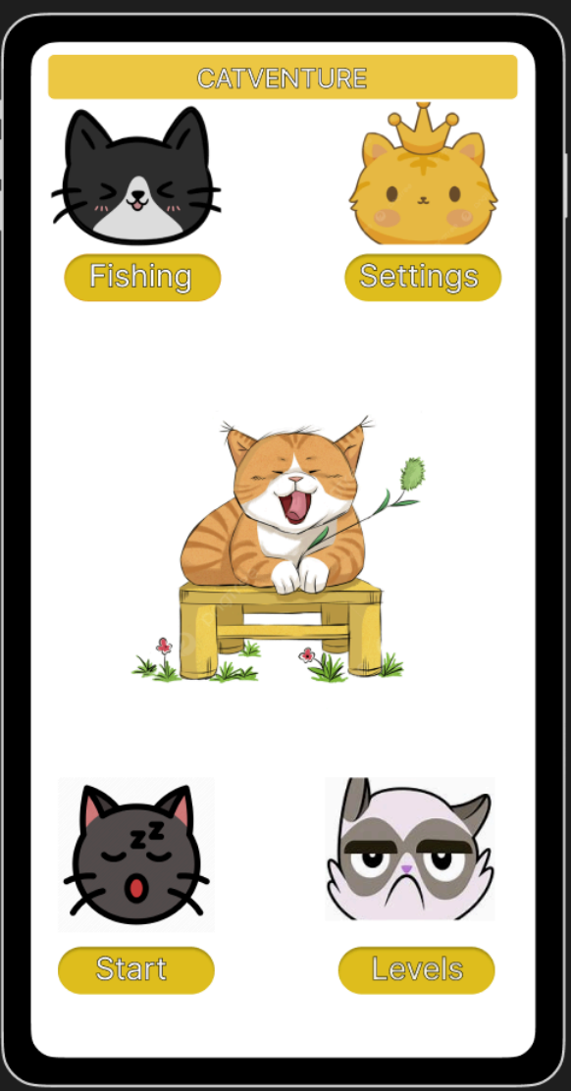

**Comparing the User Expectations with Homepage**

*Start a Game*: This is directly addressed with the "New Game" option, which enables players to start a new session, as is customary.

*Navigate to Settings*: Commonly included are the settings (for sound, controls, graphics, and difficulty). "Settings" in the wireframe suggests that it may be available while playing instead of from the main menu.

*Check What Finishing Is*: This covers activities like building, crafting, and task completion that are typical of survival or strategic games.

*Check Levels*: The user is shown a list of levels so they may see how many levels are in the same

**Wireframe: Level Page**

*Low Fidelity Design:*

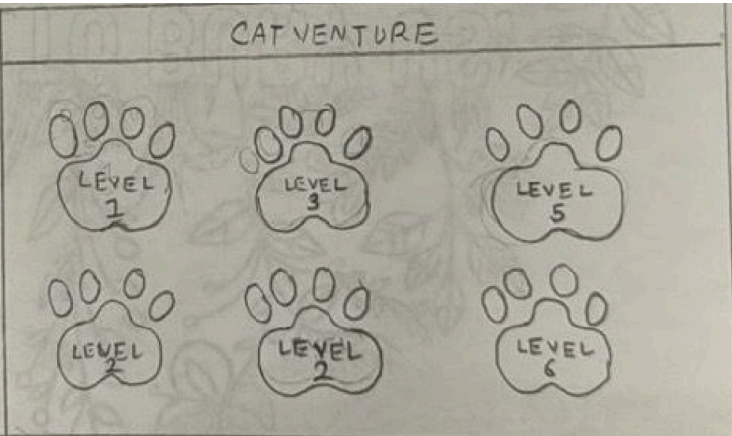

*High Fidelity Design:*

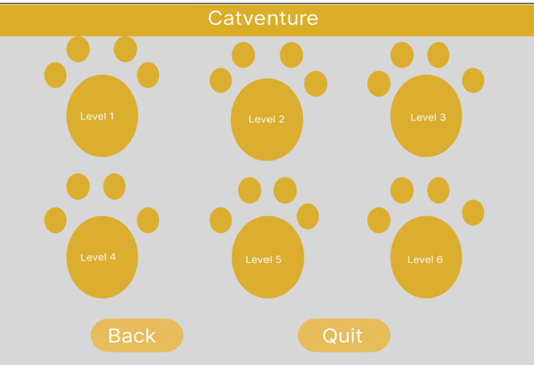

CATVENTURE's Level Page gives players a summary of their progress by showing them their finished levels, unlocked stages, and available challenges. Players have the option to move on to the next challenge or choose a level to replay.

The design of this page changes from low-fidelity to high-fidelity. It begins as a low-fidelity wireframe, concentrating on functionality and navigation and outlining the structure using straightforward boxes and text. Visual components like animations, interactive highlights, and background drawings improve user engagement as the design moves towards high fidelity. Level symbols acquire unique styles, buttons become more user-friendly, and progress indicators offer unambiguous feedback. This development guarantees that the page is both aesthetically pleasing and easy to use, complementing the game's design while preserving a smooth experience for players.

**Mockup: Level Page**

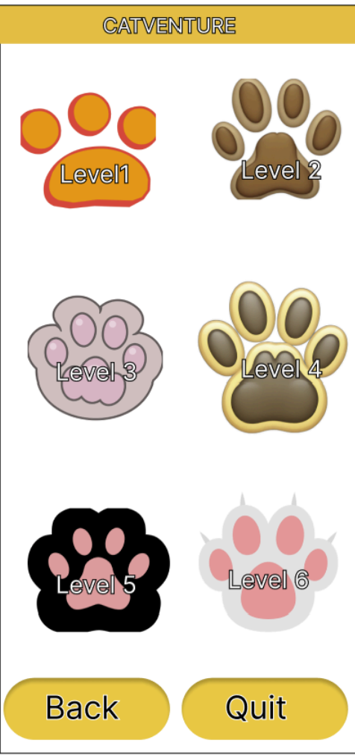 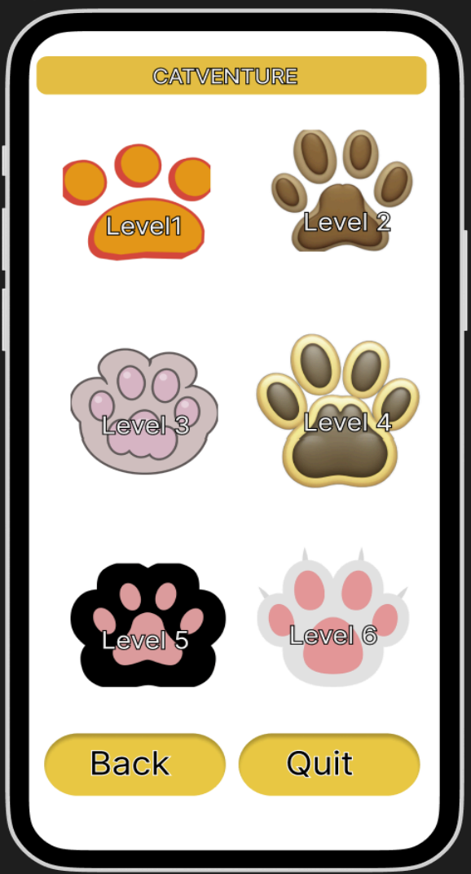

**Comparing User Expectations with the Level Page**

*Level Access*: Gamers anticipate a well-organised and unambiguous level selection screen that lets them see both locked and available stages. This assumption is directly met by the wireframe's Check Levels section, which lists levels in an orderly fashion.

*Progress tracking*: A lot of games use progress bars, badges, or stars to show when a player has finished a task. Players may see how far they've come, what's still unlocked, and whether they can relive earlier stages with a well-designed Level Page.

**Choosing a Level**: Players expect an easy-to-use interface where they can click on a level to start playing or go over earlier tasks. An accessible layout is suggested by the wireframe, but in some situations, other details, such as goals or difficulties, may be anticipated.

**Wireframe: Gameplay Page**

*Low Fidelity Design*

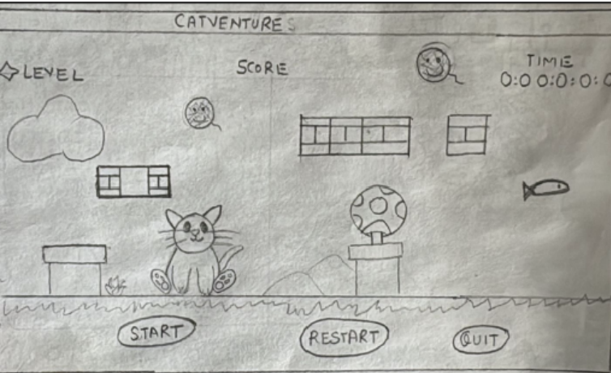

*High Fidelity Design:*

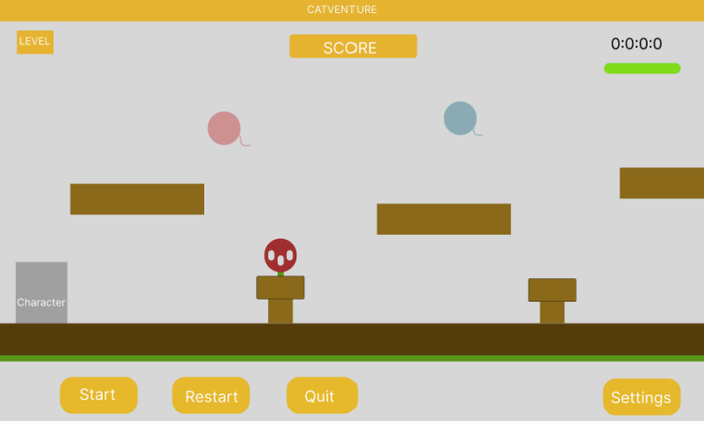

Players are fully immersed in the primary experience on CATVENTURE's Gameplay Page, where they take control of their character, explore places, finish challenges, and use features like combat or fishing. The interface makes sure players have the information they need at a glance by including crucial HUD components like objectives, inventory, and health bars.

To improve both usability and attractiveness, the design progresses from low-fidelity to high-fidelity. With an emphasis on form and accessibility, the gameplay screen is built in its low-fidelity stage utilising straightforward placeholders for character movement, UI elements, and interactions. Refined user interface features like dynamic health bars, slick iconography, seamless transitions, and captivating backdrop images increase player involvement as the game moves towards high quality. Clear feedback on activities is provided by more intuitive buttons and interactive prompts. In keeping with the overall design and user expectations, this evolution guarantees that the gameplay experience stays both aesthetically pleasing and flawlessly functional.

**Mockups: Gameplay Page**

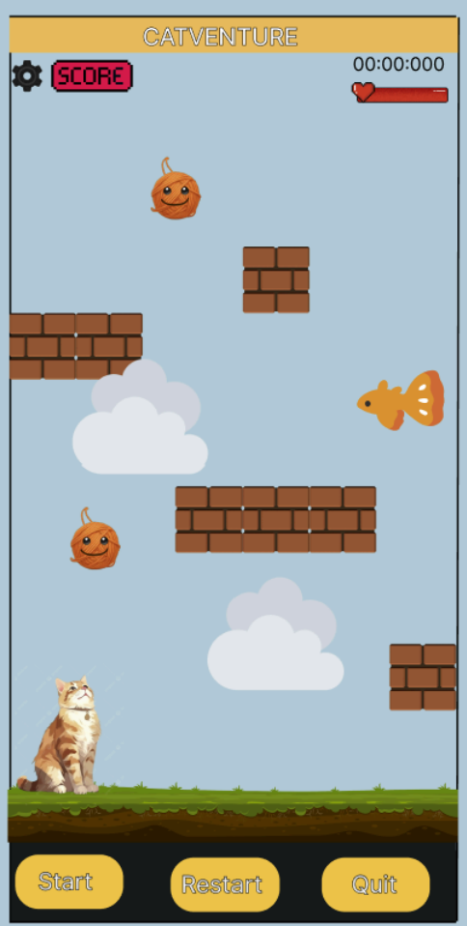 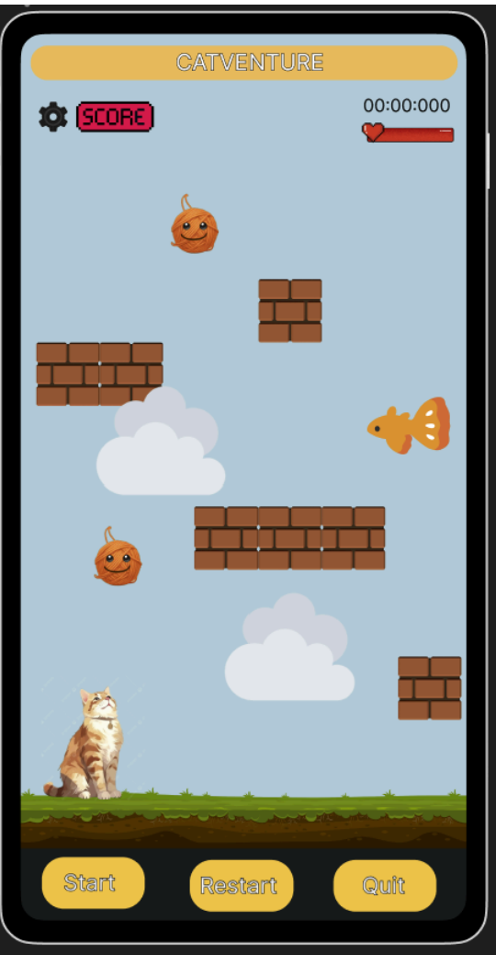

**Comparing User Expectations with the Gameplay Page**

*Character Control & Interaction*: In order to move across the environment, engage with objects, and carry out tasks like jumping, fishing, or attacking, players anticipate fluid and responsive controls. This is supported by the Gameplay Page's organised design, which places an emphasis on fluid movement and interaction features.

*HUD & Game Information*: Health bars, inventory, mini-maps, and objectives are among the key HUD components that players expect. Although the wireframe indicates a well-organised interface, usability might be further enhanced with additions like tooltips or mission markers.

*Engagement & Feedback*: Whether an attack is successful, an object is collected, or the environment changes, players anticipate visual and aural cues to validate activities. Refined user interface elements, interactive animations, and dynamic feedback are introduced during the low-fidelity to high-fidelity transition, which improves the intuitiveness of actions.

**Wireframe: Victory Page**

*Low Fidelity Design*

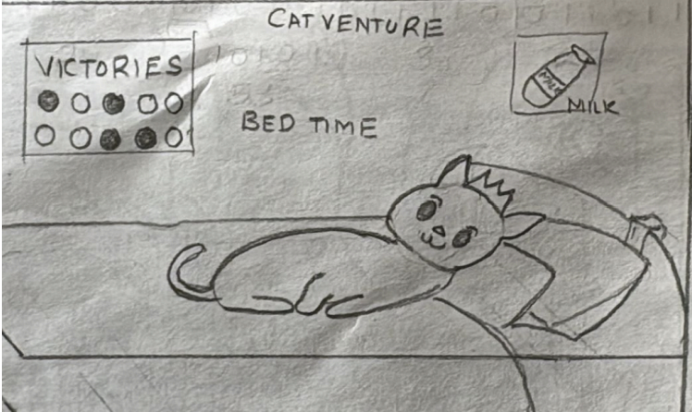

*High Fidelity Design*

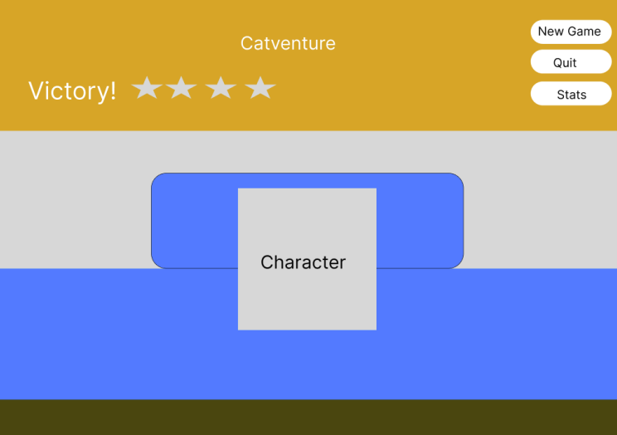

The Victory Page in CATVENTURE celebrates the player's accomplishments and provides a satisfying ending to a finished level. Key information like the level finished, awards obtained, performance statistics, and perhaps a ranking or star-based rating system are displayed. Additionally, players might have the choice to go back to the main menu, replay the current level, or move on to the next one.

This page transitions from low-fidelity to high-fidelity design. The low-fidelity wireframe first concentrates on structure and functionality, organising results, buttons, and rewards with basic text and placeholders. The website becomes more visually exciting as the design approaches high fidelity, featuring interactive highlights, animated effects, celebratory images, and captivating typography. Character motions, trophy icons, and sparkling effects are some examples of elements that improve the sense of achievement. To ensure seamless navigation, buttons have been improved to be more aesthetically pleasing and user-friendly. This change guarantees that the Victory Page is immersive and fulfilling, enhancing a feeling of accomplishment while preserving a flawless user experience.

**Mockup: Victory Page**

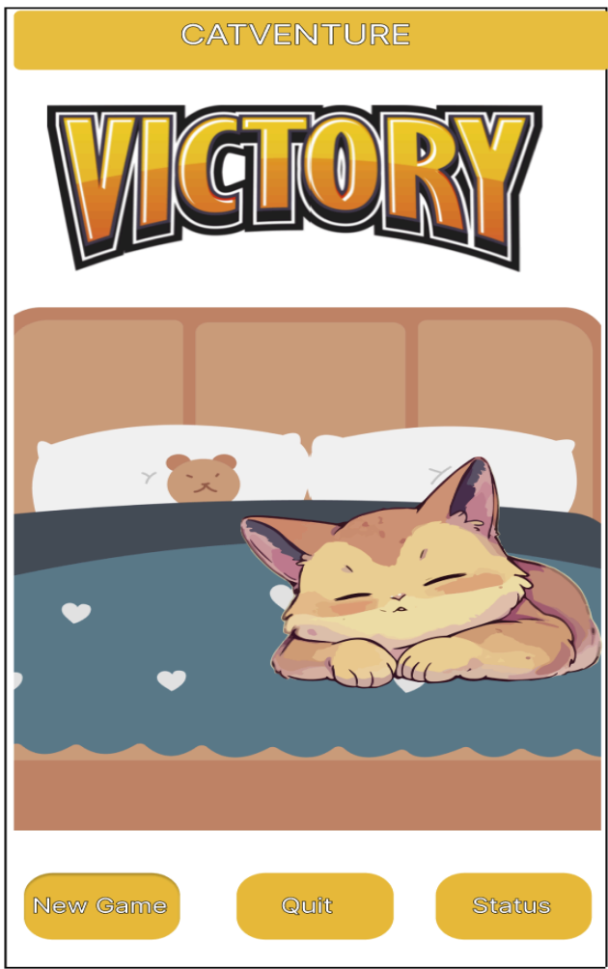 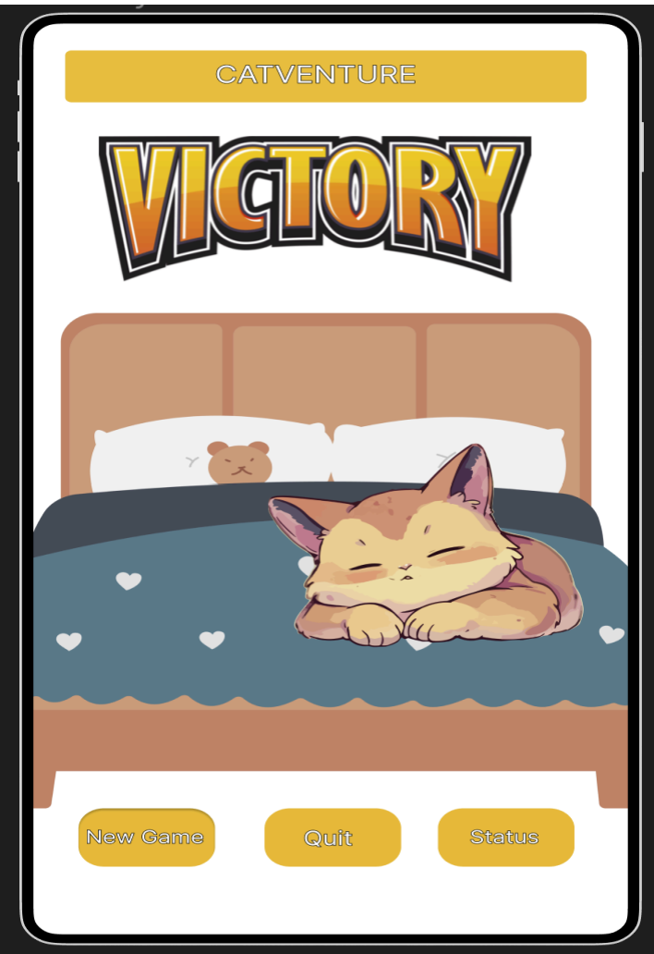

**Comparing User Expectations with the Victory Page**

*Celebration & Rewards*: Gamers anticipate that the Victory Page, which shows ranks (stars, medals, or trophies), score, and things gathered, would feel satisfying. These essential components are guaranteed by the wireframe, but sound effects and animations heighten the joyous atmosphere.

*Clear Next Steps*: Users expect alternatives like going back to the main menu, replaying the stage, or moving on to the next level to be obvious. By including clear navigation buttons, the design satisfies this need.

*Feedback & Progress Monitoring*: Gamers want to see a summary of their performance, including metrics like accuracy, time spent, and extra points. This page transforms from a simple structure to a visually rich, interactive experience with captivating animations, lively visuals, and dynamic transitions as it moves from low-fidelity to high-fidelity.

**References**

Bassel. (2024). *The role of nostalgia in gaming - GamesFandom*. Gamesfandom.com. https://gamesfandom.com/the-role-of-nostalgia-in-gaming/

Joss Querné. (2024, January 16). *🌊Give me a Flow! - Application of UX Flows in Game UX Design*. Medium. https://medium.com/@josselin.querne/give-me-a-flow-application-of-ux-flows-in-game-ux-design-6c6de77c60b8

Llach, T. (2023, May 4). *The Benefits of Game Design for Children*. Tynker Blog. https://www.tynker.com/blog/the-benefits-of-game-design-for-children/

Molina, G. (2024, December 25). *7 Best Games with Colorblind Modes, Ranked*. Game Rant. https://gamerant.com/best-games-with-colorblind-modes-ranked/

published, A. A. (2020, March 13). *The hidden value of video game main menus, and the design secrets that compel you to hit play*. Gamesradar. https://www.gamesradar.com/the-hidden-value-of-video-game-main-menus-and-the-design-secrets-that-compel-you-to-hit-play/

Team, G. (2025, March 16). *Why simple games are better?* Games Learning Society; GLS Team. https://www.gameslearningsociety.org/wiki/why-simple-games-are-better/

usorg, ngt. (2023, December 28). *Exploring the Importance of Characters in Gaming: Why They Matter and How They Enhance the Player Experience*. Ngt-Us.org; ngt us Team.